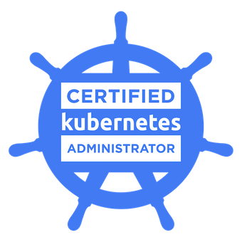
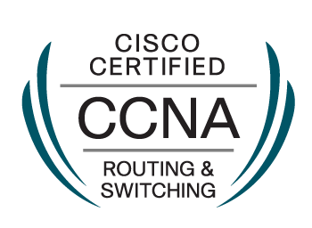

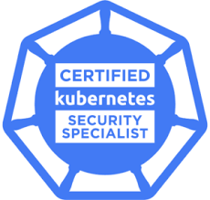

Gaurav Ahuja
E-mail: Garv4179@gmail.com
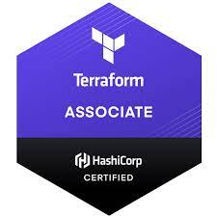
contact: +919555552424

DevOps/SRE-

Have experience of 5.7 years in DevOps profile, and looking forward to utilizing my skills and ability to achieve the organizational goal and being resourceful and innovative to become an important part of the talent pool for the company.

Sill Set
Total experience- 5.7 years
Public Cloud Applications: AWS,Azure,DO
Container Orchestration: Kubernetes, Docker, Docker Swarm, OpenShift
Operating Systems: - Linux (Centos,Linux, Ubuntu)
DNS Management: Cloudflare & Route 53
System & Application Monitoring: Zabbix, Cloud watch, Nagios
Infrastructure & Configuration Management: Ansible, Terraform
Continuous Integration/Deployment: Jenkins,GITLAB
Scripting Languages: Shell/bash Scripting, Python, Groovy
Logs or Activities: - Rsyslog, Grafana, Monitor 360
Other Tools- Jira, Confluence, Git, Wireshark, Apache, Nginx.Gitlab,Git, Github

Professional Experience

Working with

COMPANY- Builder.Ai/Engineer.ai
Designation: Site Reliability Engineer
Location: Gurgaon
Duration: 4Th September 2020 to 12th November 2021

1. working on Azure, Aws, environment to updates instances or any other work related to client requirements.
2. Working on Linux,Ubuntu,CentOs environment for more efficient and enhance work towards devops terminology.
3. Working on GitLab, Jenkins to make cicd pipelines and update repository, maintain Kubernetes ymls files.
4. Working on docker,docker swarm to maintain containers.
5. Working on Ansible to write Playbooks for client.
6. Working on Kubernetes and Openshift to make things more easier. Maintaining multi cluster application and multi cluster environment.
7. working on Shell,bash,python, Groovy for cicd pipeline.
8. Working on Cicd pipeline for maintaining the jobs,tasks.
9. Manage multi Kubernetes cluster, integrate, design and Troubleshoot the issues.
10.Provides technical administrative and configuration support for Microsoft Azure platform.
11.Procurement of necessary hardware, software, and licensing,VNET, Blob storage, instances, functions, networking, IAAS, PAAS.
12.Responsible for the engineering design, setup, configuration, maintenance, and troubleshooting of all Windows Servers and related technologies.
13. Working on Terraform scripts as per client requirements.
Professional Experience

Worked with

COMPANY- Altran
Designation: Senior Software Engineer
Location: Gurgaon
Duration: 10 January 2020 till 3rd September 2020

- Working on key technologies AWS, Linux Administration and DevOps methodologies.
- Deploy and maintain K8s clusters for team.
- Working on to Create ingress, multi pod communication, Roll base access control, Ingress, ClusterIP, NodePort, replicas, Network Overlay, S2I, cluster auto scaling, and all other activities related to OpenShift.
- Setup deployment Kubernetes to active status for clients.
- Working on to Create ingress, multi pod communication, minikube, ClusterIP, NodePort, replicas, Network Overlay, Prometheus and all other activities related to Kubernetes.
- Working on Groovy to create or maintain the CI-CD Pipelines in Jenkins.
- Working on script Groovy, Python, Shell/Bash scripting.
- Maintain pods and containers through Docker.
- Working on technologies Apache, Nginx server for making and build services.
- Working on to write the playbooks for any work related to user preference or server through Ansible.
- Test, build, design, deployment, and ability to maintain continuous integration and continuous delivery process using tools like Jenkins, Git, etc.
- Working on terraform script with AWS to maintain the infra as code.

Professional Experience

Worked with
COMPANY- HCL Technologies Noida
Designation: Speciliast
Location: Noida
Duration: 29 October 2018 to 16th October 2019

- Create ingress, multi pod communication, minikube, ClusterIP, NodePort, replicas, Network Overlay, Prometheus and all other activities related to Kubernetes and OpenShift.
- Working on AWS, Azure platform to make clients projects.
- Use Groovy for maintaining the Jenkins to make pipelines
- Working on script Groovy, python, Shell/Bash scripting.
- Use groovy scripting to fetch the docker files and images.
- Experience with automation/Orchestration tools like Ansible for creating infrastructure and managing configuration.
- Working on Groovy to create or maintain the CI-CD Pipelines in Jenkins.
- Set up centralized logging and log aggregation/searching using Elasticsearch and cloud watch log.
- Setup infrastructure & deployment pipeline for dev, test, and production environments.
- Orchestrate docker using Kubernetes.

Professional Experience
Worked with
COMPANY- Oceaneering international services
Designation: Network Engineer
Location: Chandigarh
Duration: 6th November 2017 to 26th April 2018

- Highly motivated, self-initiated and committed DevOps Engineer experienced in creating infrastructure, automating, configuring and deploying instances on AWS & Google cloud.
- Handling large production environment with servers.
- Working on Groovy, Shell, Bash to create or maintain the CI-CD Pipelines in Jenkins
- Use groovy scripting to fetch the docker files and images.
- Working on Python, Shell/Bash scripting.
- Deployment of Kubernetes, docker, docker swarm.
- Work on the Kubernetes Ingress process, Multi pod communication, Network overlays, Cluster ip and node port deployment.
- ingress, multi pod communication, minikube, ClusterIP, NodePort, replicas, Network Overlay, Prometheus and all other activities related to Kubernetes and Openshift.

Professional Experience
Worked With
COMPANY- BT Global Services Pvt Ltd
Designation: Associate Network Records
Location: Gurugram
Duration: 20th November 2015 to 4th April 2017

- Maintain pods and containers through Docker, Docker swarm.
- Working on technologies Apache, Nginx server for making and build services.
- motivated, self-initiated and committed DevOps Engineer experienced in creating infrastructure, automating, configuring and deploying instances on AWS.
- large production environment with 2000+ servers.
- Working on script Groovy, python, Shell/Bash scripting.
- Test, build, design, deployment, and ability to maintain continuous integration and continuous delivery process using tools like Jenkins, Git, etc.
- Work with Kubernetes Deployment and all other activities related to tool.
- Working on linux, ubuntu, Centos environment.
- Working on ingress, multi pod communication, minikube, ClusterIP, NodePort, replicas, Network Overlay, Prometheus and all other activities related to Kubernetes and Openshift.

Professional Experience

Worked with
COMPANY- Iyogi Technical services Pvt. Ltd.
Designation: Network Executive
Location: Gurgaon
Duration: 8thDecember 2014 to 16th November 2015

Responsibilities: -

- Manage the efficient recording, tracking and escalation of Incidents and complaints.
- Responsible to install, set up, maintain network and also configure the peripherals, cabling and equipment’s accordingly as per the requirement.
- Working as a Noc Engineer l2 handling the escalations and create and resolve the tickets.
- Know the incident management, change, Request management P1,P2,P3,P4 tickets.
- Compete monitoring of firewalls for any suspicious activity and generating report for the same.
- Configuration of Static routing, EBGP, IBGP, OSPF etc. as PE-CE routing protocol for global customers

ACADEMIC CREDENTIALS AND CERTIFICATIONS
- Completed 3 years BCA from Maharishi Dayanand UNIVERSITY Rohtak (Haryana)- 2010-2013
- XII from Delhi CBSEBOARD -2009 to 2010 from. Vivekanand Acadmey sector-7 Gurgaonekanand Academy Sector 7 Gurgaon
- X from Delhi CBSEBOARD- 2007 to 2008 from Drona Public School Ravi Nagar, Gurgaon

Professional Certificates: -
- CCNA certified routing & switching CISCO ID:CSCO12651361
- ITIL v4 foundation level certification- GR671020634GA
- CKA- Certification Kubernetes Administrator – LF- q0v0k20szb
- Azure- 104 Certified
- Terraform Certified
PERSONAL DETAILS
Name : Gaurav Ahuja
Father’s Name : Mr. Ashok Ahuja
Date of Birth : 18-07-1992
HOBBIES : Reading and learn new things about technologies.
Languages Known : Hindi, English, Punjabi
PAN CARD : AYFPA3132Q
House Number : House Number- 159-160, Bhim Nagar, Gurgaon, Haryana(122001)

Declaration: I declare that above mentioned facts are true & correct to the best of my information

